Assignment 10

Question 1 = Write a query that produces all pairs of salespeople who are living in the same city. Exclude combinations of salespeople with themselves as well as duplicate rows with the order reversed.

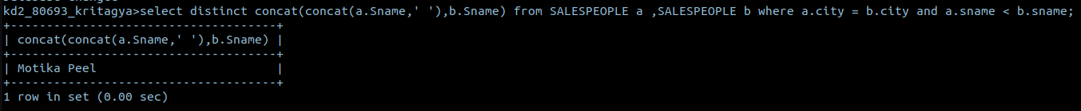

Question 2 = Write a query that produces the names and cities of all customers with the same rating as hoffman.

